TARGET
Pearson Edexcel - Specimen Papers Set 1 - Paper 2 (Calculator) Higher Tier
1.
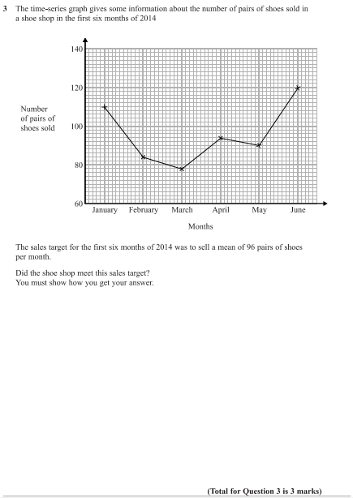

Pearson Edexcel - Friday 7 November 2014 - Paper 2 (Calculator) Higher Tier
2.
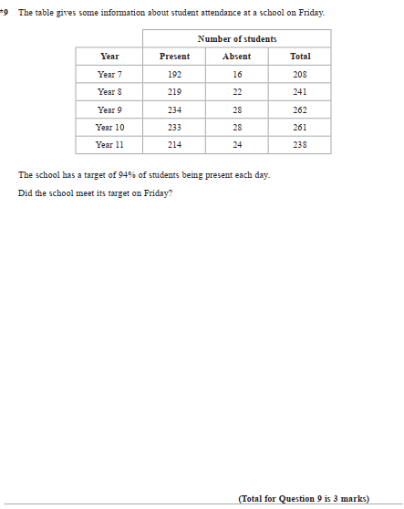
3.

